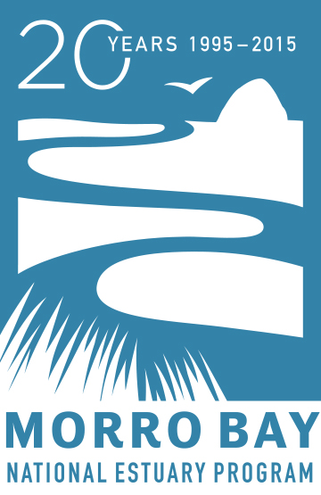

For Immediate Release: February 23, 2015

Contact: Rachel Pass
805-772-3834 ext. 13
rpass@mbnep.org

Traveling Art Show Opens: Morro Bay Estuary—Celebrating a National Treasure

Sunday, March 1, 2015

2 pm to 4 pm

Art Center Morro Bay

Morro Bay Estuary—Celebrating a National Treasure is a traveling art show that focuses on the beauty of the estuary, its wildlife, and the many ways people enjoy the bay. Artwork includes paintings, contemporary and historical photographs, and other 2-D work, as well as a series of Bay Story videos that showcase the stories of people whose lives are intertwined with the estuary. Morro Bay Estuary—Celebrating a National Treasure is a collaboration between the Morro Bay Art Association, the Historical Society of Morro Bay; the San Luis Obispo Museum of Art; the office of Deanna Richards, Edward Jones; and the Morro Bay National Estuary Program to celebrate 20 years of protecting and restoring the bay.

Morro Bay Estuary—Celebrating a National Treasure will be on display at Art Center Morro Bay between February 26 and April 13. The opening reception is Sunday, March 1, 2015, from 2 pm to 4 pm at Art Center Morro Bay (on the corner of Main St. and Morro Bay Blvd. in Morro Bay). Refreshments will be served. The Gallery is open daily from 12 pm to 4 pm. Call the gallery at (805) 772-2504 for more information.

This traveling show will then hang at the San Luis Obispo Museum of Art from April 20 to May 4, with an opening reception on Friday, May 1, from 6 pm to 9 pm during Art after Dark. Then, the show will be displayed in the office of Deanna Richards, Edward Jones, in Los Osos from May 5 through June 12. The last-look reception will take place from 5 pm to 7 pm on Friday, June 12.

Morro Bay National Estuary Program is a non-regulatory, non-profit organization that brings together citizens, local government, non-profits, agencies, and landowners to protect and restore the Morro Bay Estuary for people and wildlife. The Estuary Program has been conducting monitoring and research, restoring natural habitats, and educating residents and visitors on how to keep Morro Bay clean and healthy since 1995.

The Estuary Program will host other 20th anniversary celebrations throughout 2015 to focus attention on the bay and to teach people how to keep it clean and healthy for future generations. You can find out more about the Morro Bay National Estuary Program and our 20th anniversary events at www.mbnep.org. If you have questions, please contact Rachel Pass, Communications & Outreach Coordinator, at rpass@mbnep.org or 805-772-3834.

