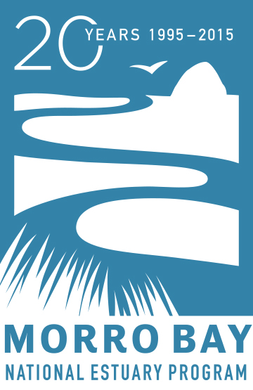

For Immediate Release: February 23, 2015

Contact: Rachel Pass
805-772-3834 ext. 13
rpass@mbnep.org

Dog Owners & Dog Lovers — Come Out to Play & Learn with Your Dogs!

DogFest 2015: Dogs for Clean Water

Saturday, March 14, 2015

City Park, Morro Bay

10am – 1pm

DogFest 2015: Dogs for Clean Water is an event for dog owners who want to have free family-friendly fun with their dogs while learning how they can help keep water clean in local creeks, the Morro Bay estuary, and Estero Bay. Activities include a dog-themed quiz with the chance to win prizes (study up at http://www.mbnep.org/mutt-mitts/), demonstrations by agility-competition dogs and local police dogs, dog-friendly giveaways, and more. All event attendees are invited to participate in our first ever Morro Bay Dog Show at noon. Prizes will be given for Best Trick, Best Dressed, and Best Dog and Owner Look-Alike. Interested dog owners can sign up when they arrive, or send their name, their dog’s name, and the contest categories they’d like to enter to staff@mbnep.org to register beforehand. Local vendors will showcase dog-related items and services, and light snacks will be available (donations accepted). All dogs must be on leash and well-behaved. Dogfest 2015: Dogs for Clean Water will be held Saturday, March 14, 2015 from 10 am to 1 pm at City Park in Morro Bay (on the corner of Morro Bay Blvd. and Harbor St. in Morro Bay).

DogFest promotes the popular Morro Bay Mutt Mitts program that the Morro Bay National Estuary Program has managed since 2005. Dedicated Mutt Mitts program volunteers and staff from the City of Morro Bay and the Estuary Program are organizing DogFest to raise awareness about the importance of picking up pet waste. This simple action helps keep bacteria out of local creeks and the bay. Bacterial contamination from dog waste can cause illness and harms water quality. Thanks to the help of many committed volunteers, generous business sponsors, and private donors, the Mutt Mitts Program provides free Mutt Mitts at more than 20 dispensers strategically located at parks throughout Morro Bay. Mutt Mitts are disposable, degradable bags used to pick up dog waste.

Dogfest 2015: Dogs for Clean Water is proudly put on by the Morro Bay Mutt Mitts program, which is managed by the Morro Bay National Estuary Program, and the City of Morro Bay. Morro Bay National Estuary Program is a non-regulatory, non-profit organization that brings together citizens, local government, non-profits, agencies, and landowners to protect and restore the Morro Bay Estuary for people and wildlife. The Estuary Program has been conducting monitoring and research, restoring natural habitats, and educating residents and visitors on how to keep Morro Bay clean and healthy since 1995.

The Estuary Program will host other 20th anniversary celebrations throughout 2015 to focus attention on the bay and to teach people how to keep it clean and healthy for future generations. You can find out more about the Morro Bay National Estuary Program and our 20th anniversary events at www.mbnep.org. If you have questions, please contact Rachel Pass, Communications & Outreach Coordinator, at rpass@mbnep.org or 805-772-3834.

