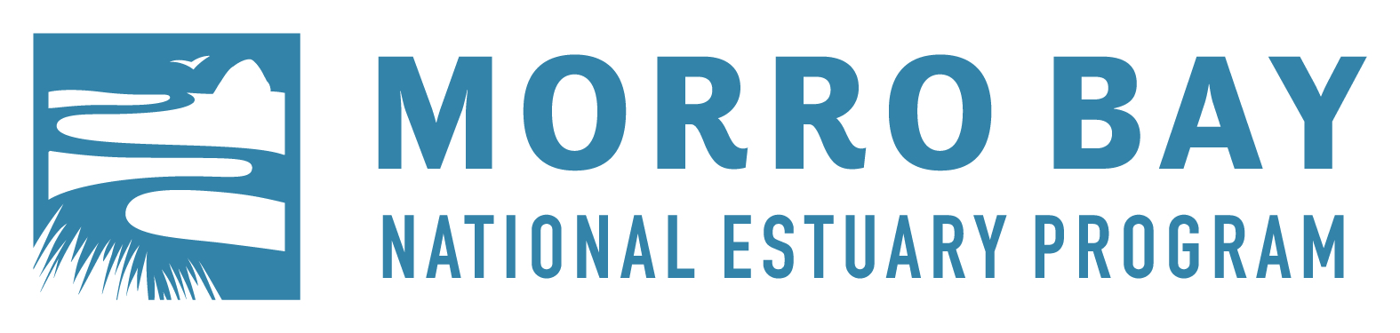

Morro Bay National Estuary Program

Implementation Committee Quarterly Meeting May 5, 2016
Windows on the Water - 699 Embarcadero, Morro Bay 12:00 pm

DRAFT Minutes
Attendees: Vince Cicero, CA State Parks; Cathie Martin, County of San Luis Obispo; Mike Anderson, CCC; Michaela Koenig, CalTrans District 5; Brian Meux, NOAA; Lexie Bell, MBNEP Staff; Jen Nix, MBNEP Staff; Rachel Pass, MBNEP Staff; Sara Markham, MBNEP Staff; Cynthia Milhem, MBNEP Staff; Ann Kitajima, MBNEP Staff.

- Introductions and Updates
- Mike Anderson – The CCCs have some new crew supervisors. They are still seeking a new Director. They will soon be working on SWAP land on a restored area to clean-up, do some re-planting, and put up fencing to protect the area. Future work in the watershed might include working with Morro Coast Audubon Society on Veldt grass removal and updating paths to be ADA compliant.
- Jen Nix – Jen is wrapping up her time with the NEP and about to begin her new position with the Coastal San Luis Resource Conservation District.
- Cathie Martin – The county is working on a sustainable groundwater management feasibility study.
- Vince Cicero – State Parks is conducting some fuel and forestry management on Black Hill for safety reasons and to create a healthier community. They have also been doing work with Saharan mustard removal.
- Rachel Pass – The poetry contest just ended, and judging is now underway. There will be a reading on May 20 at Coalesce books. Dogfest will be held on Sunday, May 15. It’s a dog-focused public event to educate the public on picking up after their pets.
- Becka Kelly – The dredger has arrived in Morro Bay. Dredging is schedule to occur for 28 days in May. A turbidity study will be ongoing at the same time to ensure that water quality is not being negatively impacted. This round of dredging will be focused in the northern part of the harbor. Funding is in place to dredge further south in the bay as well as at State Park Marina later in the year. The city will be holding a Boating Safety Day on May 21 at the Yacht Club.

- Public Comment – None presented.

- Presentation: Morro Bay in Bloom Rainwater Harvesting Project Community Grant Update

The presenter, a representative from Morro Bay in Bloom, was scheduled to talk about the Rainwater Harvest Project Community Grant. Unfortunately he had to cancel at the last minute due to illness, so he will be re-scheduled for a future meeting.

- Agenda Revisions: Morro Bay in Bloom Rainwater Harvesting Project Community Grant Update

Presentation by Morro Bay in Bloom will be re-scheduled to a future meeting.

- ACTION: Consider Approval of February 4, 2016 minutes

Vote: Mike Anderson motioned to approve, Michaela Koenig seconded. Unanimous in favor.

- ACTION: Recommendations on Community Grant Applications
SeaLife Stewards: The group had questions about who owned the equipment and about the liability implications. The equipment is not owned by the NEP, and the liability is covered by the State Parks policy. There were questions about other areas where this type of effort has happened, whether it is sustainable, and whether data would be collected. The effort has gone on for many years in Monterey Bay in a program called Team OCEAN. The group collects data about wildlife disturbance, and their data shows the efficacy of this effort in reducing wildlife disturbances.

Morro Bay Boatyard and Haulout Facility: Staff provided an update that since the staff report was written, the City Council had voted to commit $50,000 towards the Financial Feasibility Study but directed staff to not start the effort until they saw how far the private for-profit entity went in the process. This would avoid duplication of effort and could result in cost savings for the city.

Proposal Development Support for Green Infrastructure and Storm/Rain Water Catchment: The group was supportive of the goal of improving stormwater management on Camp San Luis Obispo. However, given the uncertainties of the competitive grant process, the group felt that they preferred to support the effort with funds for implementation.

Vote: Carla Wixom motioned to approve the Sealife Stewards Grant, approve the Morro Bay Boatyard Facility Grant (contingent upon the City of Morro Bay formally authorizing moving forward with a feasibility study), and to not approve the Green Infrastructure Grant request. Vince Cicero seconded. Unanimous in favor.

- ACTION: Recommend Approval of FY17 Workplan and CWA 320 Grant Application
Estuary Program staff highlighted the new tasks in the FY17 Workplan, including a Nature Center Update, State of the Bay report and events, and a project development task.
Vote: Vince Cicero made a motion to recommend to the EC approval of the proposed Workplan. Carla Wixom seconded. Unanimous in favor.

- Discussion: Potential Funding and Monitoring Efforts for Eelgrass – Status and Next Steps
Staff provided an overview of eelgrass-related monitoring efforts. There were three additional items that Jen Nix added to the list:

- San Francisco State University and Cal Poly have an ongoing collaborative effort looking at eelgrass wrack and Suaeda californica. Jennifer O’Leary and Jenn Yost of Cal Poly are involved in the project to cage Suaeda plants around the bay and in the Los Osos area.
- CDFW has instrumentation in the bay to measure water quality conditions near eelgrass beds. In an agreement with Cal Poly, faculty member Ryan Walters will now be responsible for the download and analysis of the data.
- Jen spoke with Brian Meux of NOAA. His request for internal funding to support Cal Poly research efforts will likely not be funded, but it is an important relationship to maintain.

- Discussion: Presentation of EPA Semi-annual Report

Staff clarified an error in the staff report regarding the budget spent in the 320 grant. The staff report should have read as follows: “As of March 2016, 79% of the 320 funds from the grant that began in FY12 have been spent. $256,073 has been spent from October 1, 2015 through March 31, 2016.”

- Adjourned at 1:30 pm to next meeting of August 4, 2016 at 12:00 pm at Windows on the Water.
Attachments sent with Staff Report:
    - February IC meeting minutes
    - FY17 Workplan
    - Community grant applications
    - EPA Semi-annual Report

