Updates from the Field: Monitoring Eelgrass Expansion
[Featured Image: “20210224_T21_eelgrassblog.jpg”]
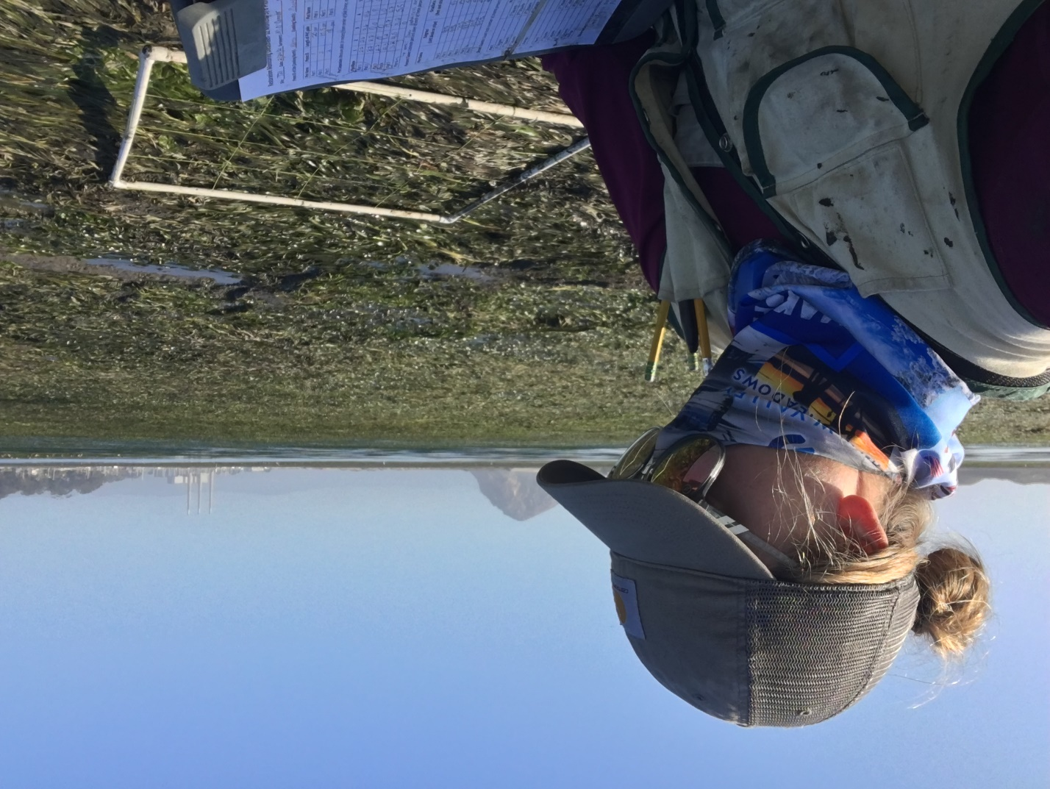
[Text]
The Morro Bay National Estuary Program's fieldwork has been deemed an essential service by the County of San Luis Obispo. Due to COVID-19 safety precautions, we are not working with volunteers at this time and our field staff are following updated monitoring protocols. We look forward to working with volunteers and other community members again as soon as it is safe for us to do so. Thank you, readers, for staying engaged and supporting the Estuary Program's work during this difficult time.

Green, green, everywhere!
If you’ve been out on the bay recently, especially at a low tide, you might have noticed things are looking significantly greener than the past few years. Why, you may ask?
If you guessed a major uptick in eelgrass coverage, you’d be right! Eelgrass (Zostera marina) is a flowering marine plant found in Morro Bay that serves many ecological functions. These include, but are not limited to, water clarity, oxygenation, and providing refuge for aquatic wildlife.
[Photo: “Eelgrass and heron and gull.jpg”]
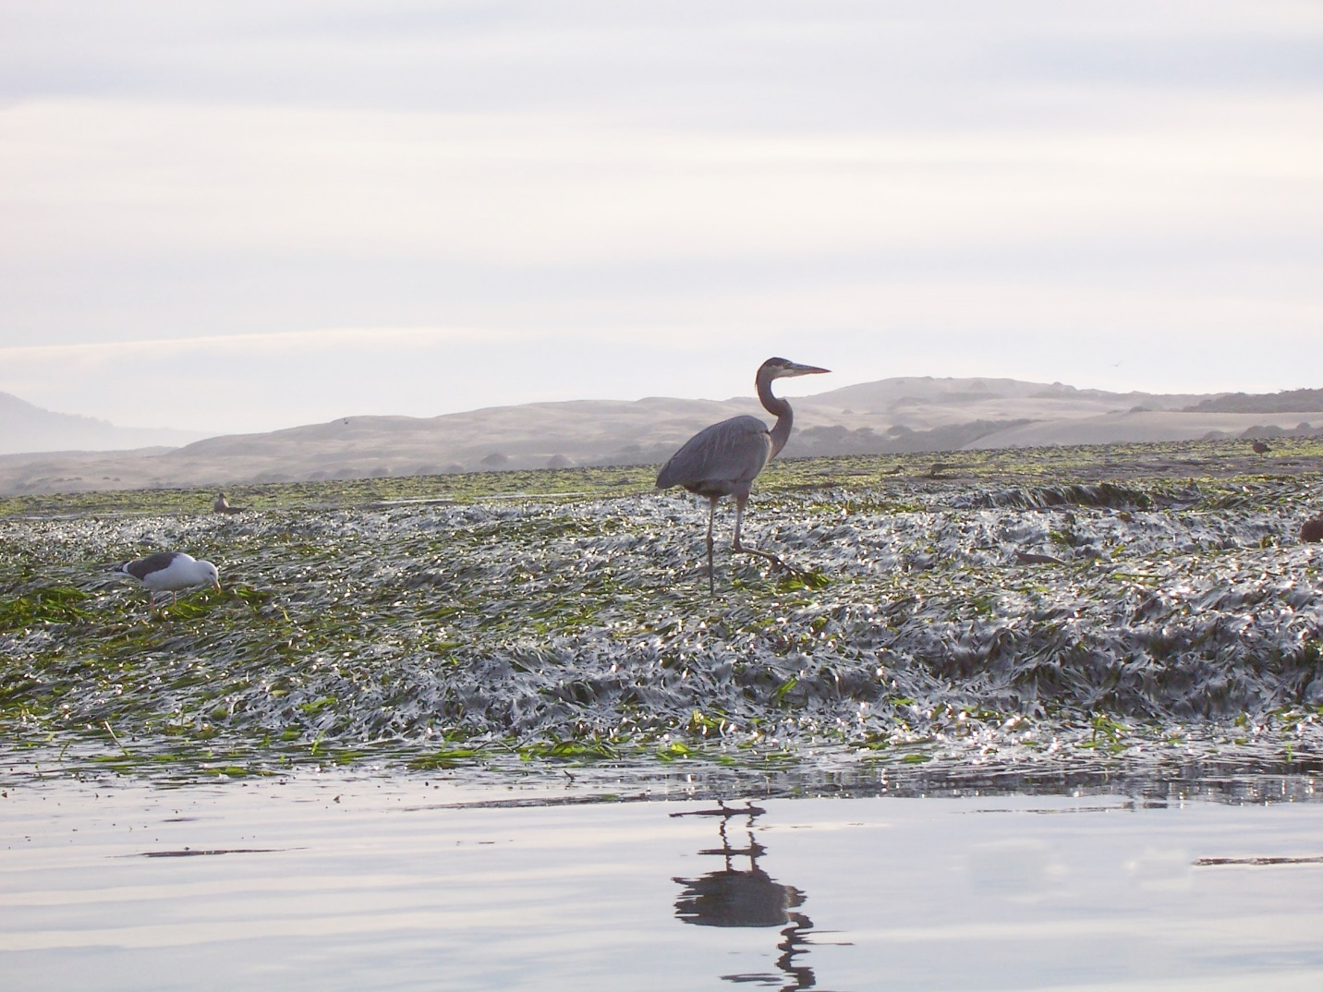
[[caption] Eelgrass provides refuge and foraging opportunities for marine wildlife, including the heron and gulls pictured here. [/caption]
The Estuary Program has been monitoring eelgrass in Morro Bay since the early 2000’s, and found a significant reduction in eelgrass acreage during 2017. Mapping efforts in 2007 had indicated nearly 350 acres of eelgrass by 2017, only thirteen acres remained in the bay: a decline of more than ninety-five percent.
Reasons for this drastic decline have been speculated, but to date, there is no exact cause known to have led to the decline.
[Photo: “20171202_mar.jpg”]
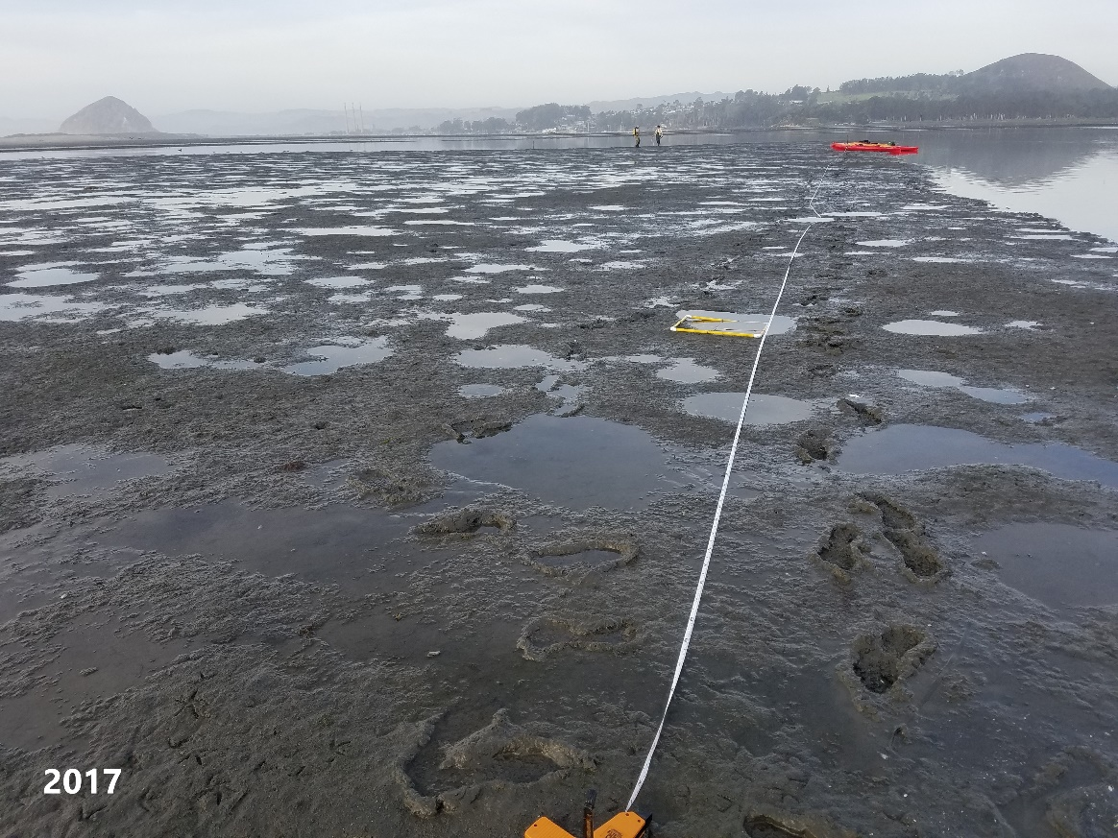
[[caption] This photo shows an eelgrass monitoring site from 2017. No eelgrass was recorded during this survey. [/caption]
Although Morro Bay has seen a major decline in eelgrass over the past 20 years, things seem to be moving in a better direction in more recent years. Our most recent estimate from 2019 indicated that eelgrass acreage was at about forty-two acres, meaning that the Morro Bay eelgrass population had more than tripled since 2017.
[Photo: “eelgrasscomparison.jpg”]
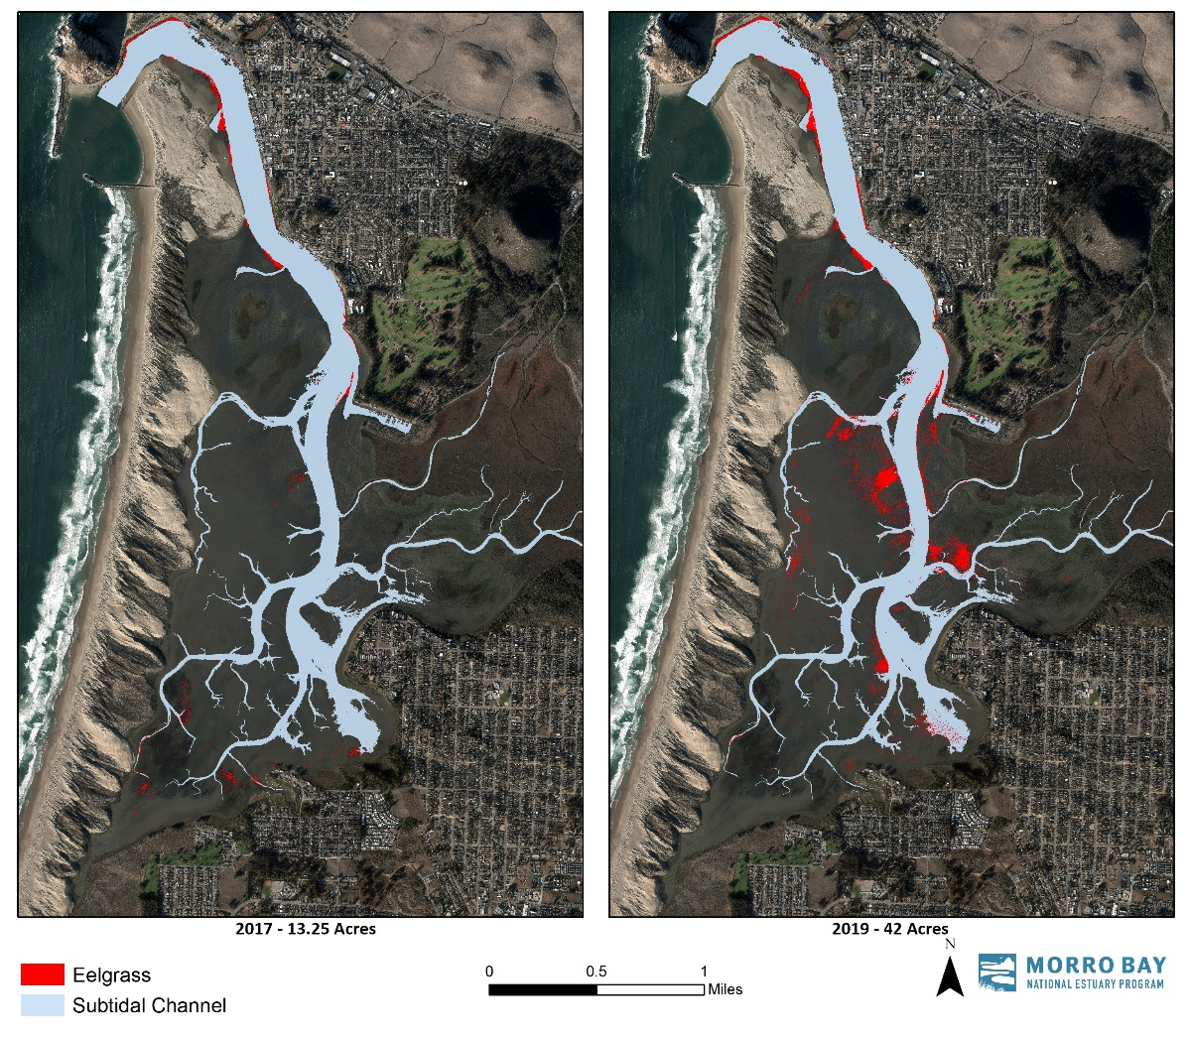
[[caption] Eelgrass acreage has more than tripled in Morro Bay since 2017. This map compares the extent of eelgrass in 2017 (13.25 acres) and in 2019 (42 acres). [/caption]
This expansion of eelgrass has also been documented in the Estuary Program’s annual eelgrass monitoring. Certain locations in the bay have been chosen for routine annual monitoring, with the idea to capture regional differences between the front, mid and back bay. These locations range from the mouth of the bay, at Coleman Beach (near Morro Rock), to the back of the bay, just south to Pasadena Point, in Los Osos.
While some sites are still working to get back to pre-decline levels, other sites like one site near State Park Marina, has had more eelgrass than we’ve ever documented.
[Photo: “MAR Time Series - 2020.jpg”]
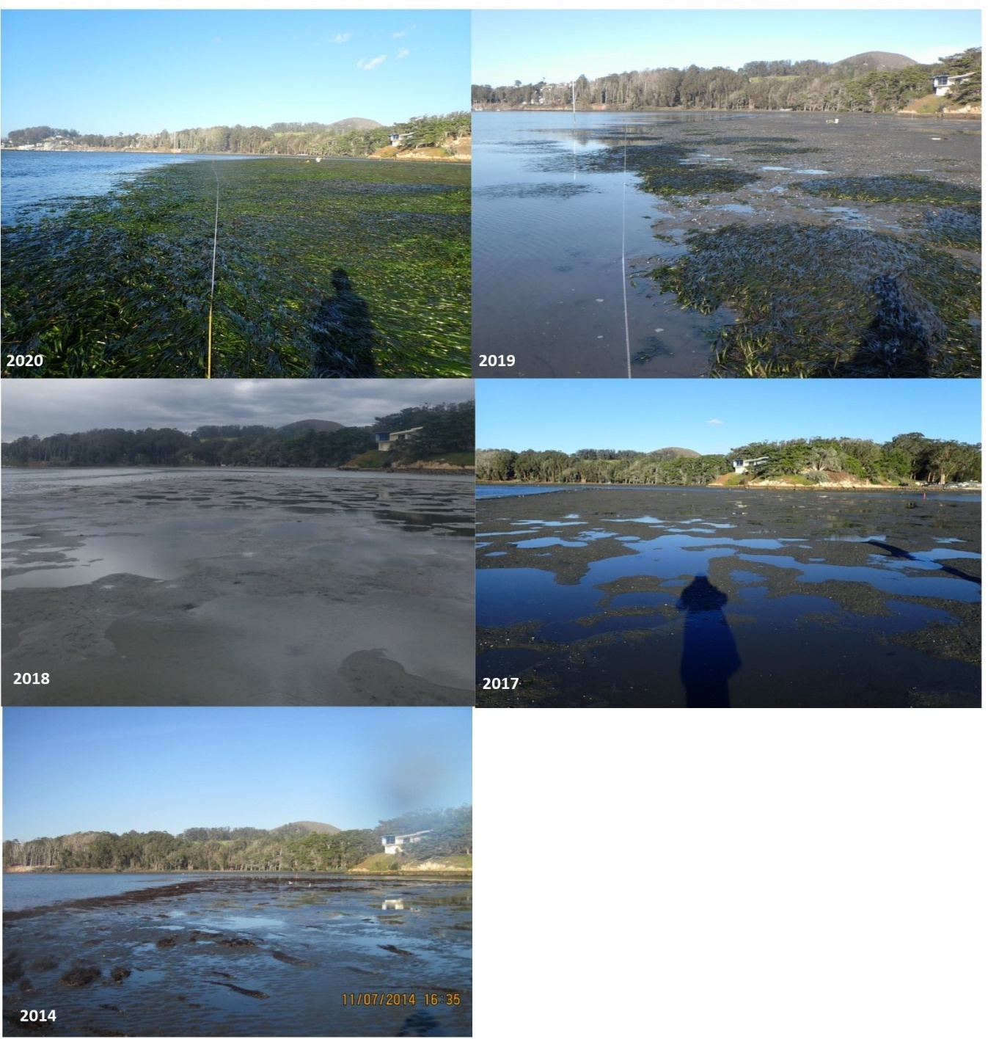
[caption] This photo shows a time series from one of our eelgrass monitoring sites near State Park Marina in Morro Bay that has seen more eelgrass than we’ve ever documented! [/caption]
The photo above shows a time series at the same location near State Park Marina, from 2014 to 2020. As documented in 2014, 2017 and 2018, nearly no eelgrass exists within the monitoring location. In 2019, new patches of eelgrass began forming. By 2020, these small patches had significantly expanded, creating one cohesive eelgrass bed.
While we still have a way to go before we get back to 300+ acres of eelgrass in the bay, it’s exciting and invigorating to see a rebound in eelgrass acreage.
[Photo: “MAR Time Series - 2020.jpg”]
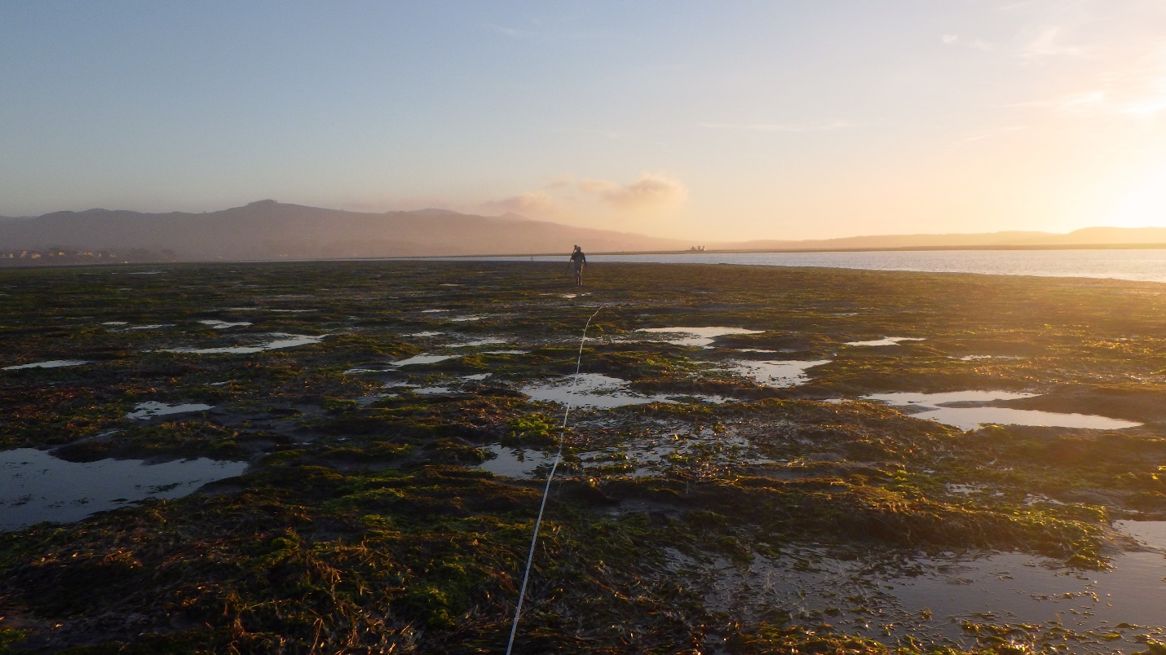
[caption] Sunset monitoring eelgrass in Morro Bay. [/caption]
Interested in hearing more? You can stay up to date with all things fieldwork related by subscribing to our blog. We put out weekly posts and field updates on the first Friday of every month. Subscribe here to never miss a post!

Help protect and restore the Morro Bay estuary
- Donate to the Estuary Program and support our work in the field, the lab, and beyond.
The Estuary Program is a 501(c)3 nonprofit. We depend on funding from grants and generous donors to continue our work.
- Support us by purchasing estuary-themed gear from ESTERO. This locally owned and operated company donates 20% of proceeds from its Estuary clothing line and 100% of Estuary decal proceeds to the Estuary Program. Thank you, ESTERO!
- Purchase items from the the Estuary Program's store on Zazzle. Zazzle prints and ships your items, and the Estuary Program receives 10% of the proceeds. Choose from mugs, hats, t-shirts, and even fanny packs (they're back!) with our fun Estuary Octopus design, our classic Estuary Program logo, or our Mutts for the Bay logo.
Thank you for your support!

