Field Updates March 2021: Volunteer Monitoring Program Updates and Bioassessment Site Scouting
[Featured Image: “UpperPennington_sitescout.jpg”]
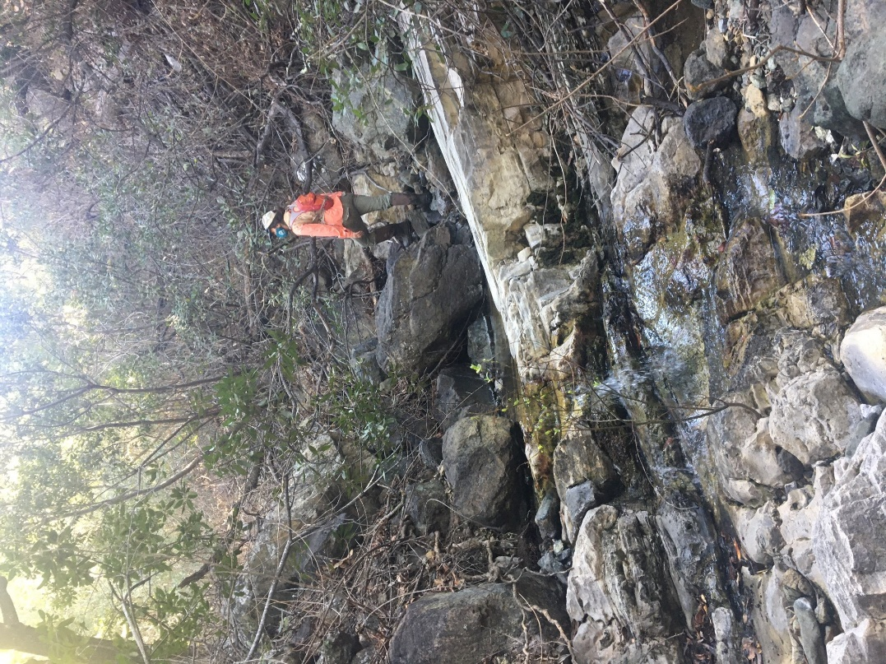
[Text]

Updates on the Volunteer Monitoring Program
As of March 2nd 2021, San Luis Obispo County moved from the purple or “Widespread” tier back into the red tier. The Morro Bay National Estuary Program’s current COVID-19 Safety Policy allows for volunteer monitoring when the San Luis Obispo County risk level is at or below the red tier designation, as outlined by COVID19.ca.gov. As such, the Estuary Program has slowly begun inviting back volunteers in a limited capacity.
This change has been coupled with additional safety precautions and augmented protocols to ensure the safety and well-being of volunteers and staff. These include but are not limited to: self-screening for symptoms, social distancing, and mask and glove wearing.
Volunteers are also encouraged to get vaccinated when they become eligible. More information on COVID-19 vaccination eligibility can be found at myturn.ca.gov.
While the Estuary Program is thrilled to have volunteers back after nearly a year, the Volunteer Monitoring Program will not be training any new volunteers until it is safe and feasible to do so. This being the case, the Estuary Program will not be inviting volunteers for our annual spring bioassessment surveys until 2022. Instead, the bioassessment season will be conducted by a limited number of trained staff, similar to the 2020 bioassessment season.
[photo: 2020_CLK_blake.jpg]
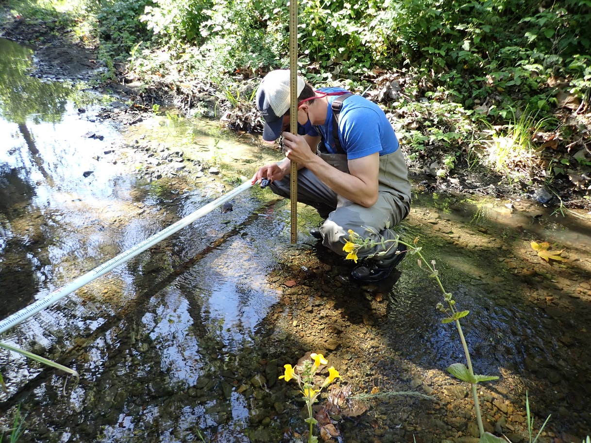
[caption] Estuary Program field technician, Blake Toney, measures pebble sizes as a part of the 2020 Bioassessment effort on Upper Los Osos Creek. [/caption]

Scouting Sites for Bioassessment
A lack of flow and high temperatures in the Morro Bay watershed has fast-tracked our spring bioassessment season start date to mid-April, instead of our typical start-date in mid-May. With this start-date approaching quickly, Estuary Program staff have been coordinating and scouting out potential sites for the 2021 season.
[photo: flow1]
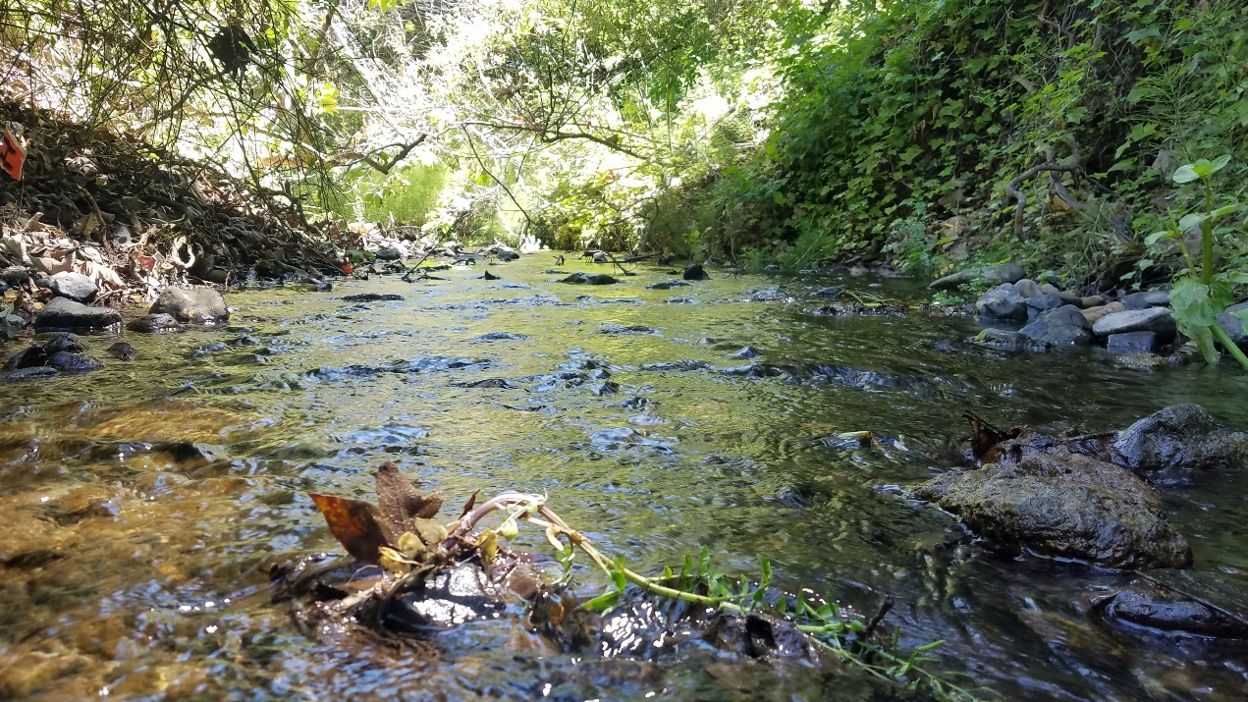
[caption: Low flow in our local creeks has fast tracked bioassessment season planning. Estuary Program staff will begin conducting surveys in mid-April, nearly a month earlier than usual. [/caption]
Prior to conducting bioassessment surveys, Estuary Program staff need to scout out each site for feasibility, site conditions, and general macroinvertebrate distribution. Given the still-present concern around COVID-19, staff are also keeping a close eye on how much social distance can be maintained while surveying certain segments of the creek. Sites where social distance cannot be adequately maintained may be excluded from the 2021 survey.
A typical day of bioassessment site scouting includes walking the 150 meter stretch of creek that will be surveyed, flipping over rocks to look for macroinvertebrates, and taking lots and lots of photos.
[photo: 20210330_CER_caddis.jpg]
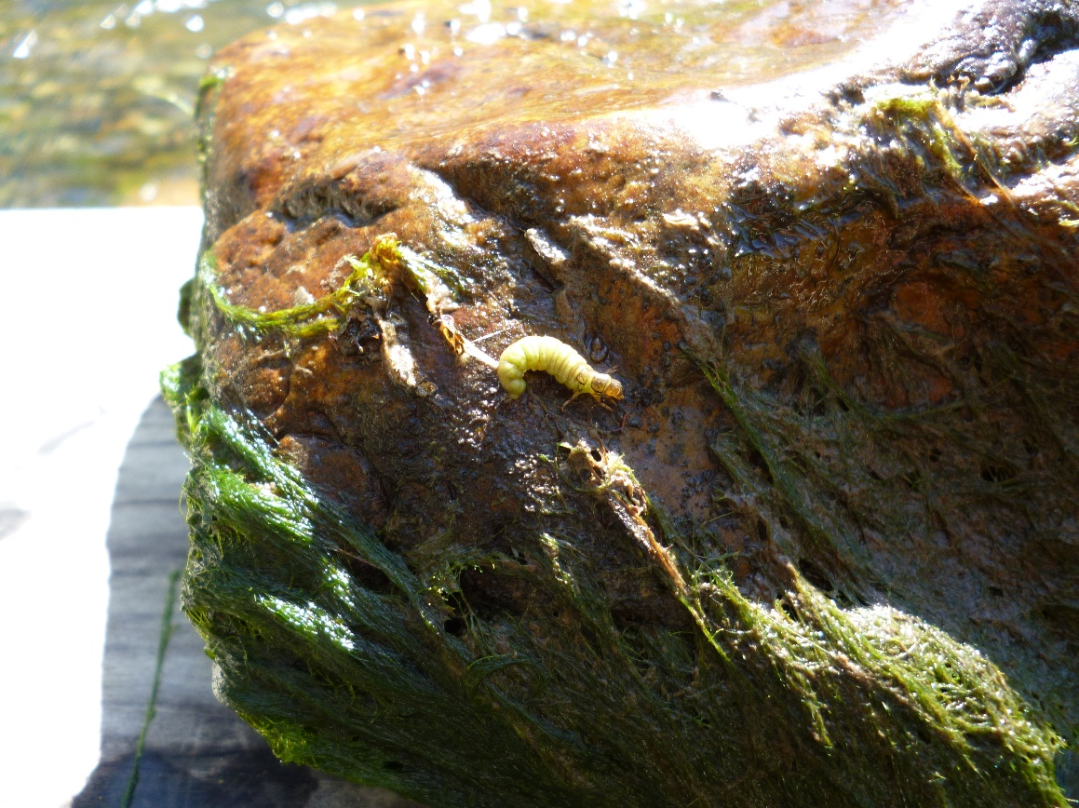
[caption] This photo shows a picture of a free-living caddisfly found during a bioassessment site scout on Chorro Creek. [/caption]

During the 2021 season, the Estuary Program hopes to survey a new site toward the upper portion of Pennington Creek. Staff scouted this site last month to find lots of great habitat, and cool, clear water. This site may be used as a reference site, to compare to more impaired waters downstream.

[photo: upperpennington2.jpg]
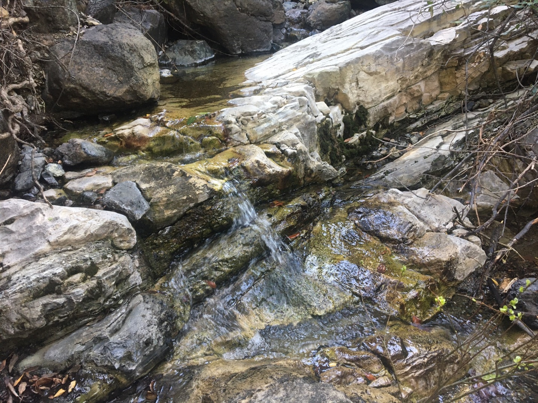

[caption] Cool, clear water runs over bedrock at Upper Pennington Creek. [/caption]

For more information on the results from last year’s bioassessment effort, be sure to check out this blog post.

Upcoming Posts
Estuary Program staff have a busy month ahead, with the 2021 bioassessment season beginning, eelgrass monitoring and the return of volunteers, as well as routine water quality and bacteria monitoring.

Be sure to stay tuned for next month’s field updates post, by subscribing to our blog.

Help protect and restore the Morro Bay estuary
- Donate to the Estuary Program and support our work in the field, the lab, and beyond.
The Estuary Program is a 501(c)3 nonprofit. We depend on funding from grants and generous donors to continue our work.
- Support us by purchasing estuary-themed gear from ESTERO. This locally owned and operated company donates 20% of proceeds from its Estuary clothing line and 100% of Estuary decal proceeds to the Estuary Program. Thank you, ESTERO!
- Purchase items from the the Estuary Program's store on Zazzle. Zazzle prints and ships your items, and the Estuary Program receives 10% of the proceeds. Choose from mugs, hats, t-shirts, and even fanny packs (they're back!) with our fun Estuary Octopus design, our classic Estuary Program logo, or our Mutts for the Bay logo.
Thank you for your support!

